EXPERIMENT 4
Demonstrate data visualization, histograms and multiple variable summaries.

AIM
To demonstrate data visualization techniques using histograms, scatter plots, and multiple variable summaries on COVID-19 and other datasets.

PROCEDURE
- Import pandas, matplotlib, sklearn (MinMaxScaler).
- Load the worldometer_coronavirus_daily_data.csv.
- Inspect dataset using data.tail() and data.info().
- Drop nulls and duplicates; convert 'date' to datetime.
- Select numeric columns: daily_new_cases, daily_new_deaths, active_cases, cumulative_total_cases.
- Apply MinMaxScaler to normalize the numeric data.
- Plot a scatter plot of Scaled Daily Cases vs Scaled Daily Deaths.
- Plot a histogram of scaled daily new cases (xlim 0 to 0.1).
- Compute descriptive statistics using scaled_data.describe().
- Plot multiple variable box plots using scaled_data.plot(kind='box').
- Compute and print the correlation matrix.
- Visualize the correlation matrix using imshow with coolwarm colormap.

CODE

import pandas as pd
import matplotlib.pyplot as plt
from sklearn.preprocessing import MinMaxScaler
data = pd.read_csv('worldometer_coronavirus_daily_data.csv')
data.tail()
data.info()
data = data.dropna()
data = data.drop_duplicates()
data['date'] = pd.to_datetime(data['date'])
numeric_data = data[['daily_new_cases','daily_new_deaths',
'active_cases','cumulative_total_cases']]
scaler = MinMaxScaler()
scaled_data = pd.DataFrame(
scaler.fit_transform(numeric_data),
columns=numeric_data.columns
)
# Scatter plot
plt.scatter(scaled_data['daily_new_cases'], scaled_data['daily_new_deaths'])
plt.xlabel('Scaled Daily Cases')
plt.ylabel('Scaled Daily Deaths')
plt.title('Scatter Plot after Scaling')
plt.show()
# Histogram
plt.hist(scaled_data['daily_new_cases'], bins=30)
plt.xlim(0, 0.1)

plt.xlabel('Scaled Daily Cases')
plt.ylabel('Frequency')
plt.title('Histogram of Scaled Daily Cases')
plt.show()
# Summary statistics
scaled_data.describe()
# Multiple variable boxplot
scaled_data.plot(kind='box', figsize=(8,5), showfliers=False)
plt.title('Multiple Variable Summary (Scaled Data)')
plt.show()
# Correlation matrix
corr_matrix = numeric_data.corr()
plt.imshow(corr_matrix, cmap='coolwarm')
plt.colorbar()
plt.xticks(range(len(corr_matrix.columns)), corr_matrix.columns, rotation=45)
plt.yticks(range(len(corr_matrix.columns)), corr_matrix.columns)
plt.title('Correlation Matrix')
plt.show()

OUTPUT
Scaled Data Summary (describe): count: 142154 rows for all columns mean daily_new_cases: 0.004067
mean daily_new_deaths: 0.015478

Correlation Matrix highlights: daily_new_cases vs active_cases: 0.810888
daily_new_cases vs cumulative_total_cases: 0.568780

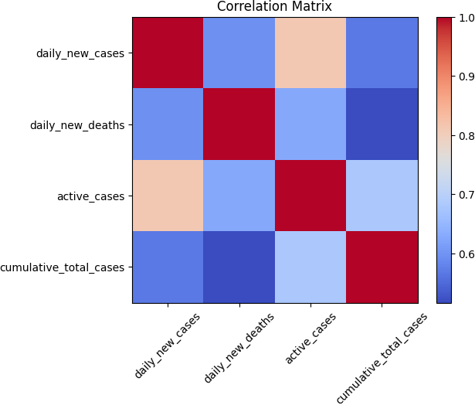
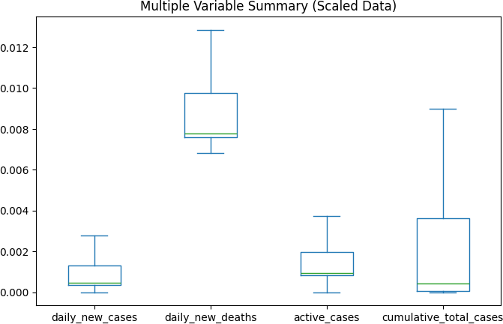

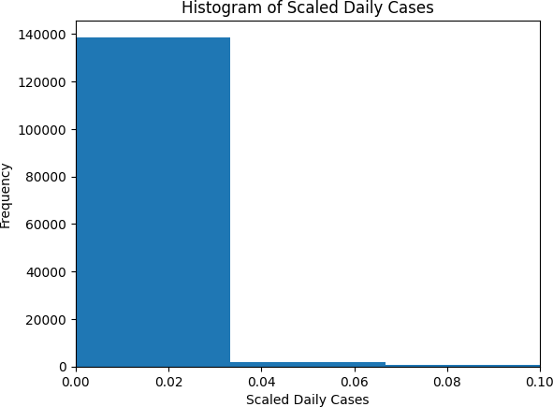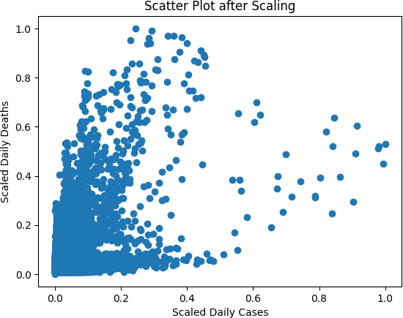

RESULT
Data visualization revealed a right-skewed distribution in daily new cases. The correlation matrix showed a strong positive correlation (0.81) between daily new cases and active cases. MinMax scaling normalized the data for fair cross-variable comparison.

